1. Repositorio en GitHub: <https://github.com/freezersharp/CursoDominioTIC>
2. Diagrama E-R:

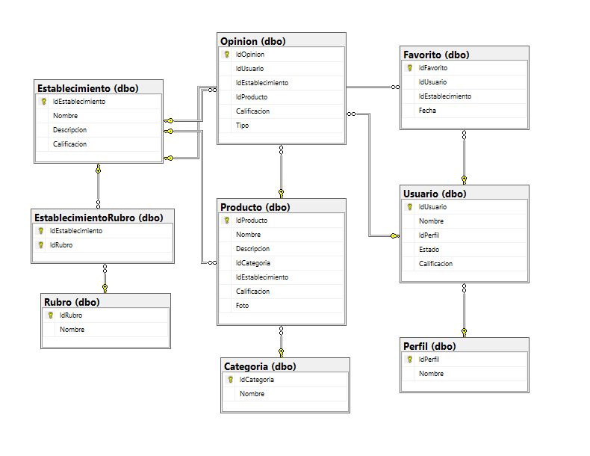

1. Script: https://github.com/freezersharp/CursoDominioTIC/blob/master/ScriptDB.sql

Server: freezersharp.database.windows.net

Base de datos:

